**Multi Maps using Tableau**

**A)**

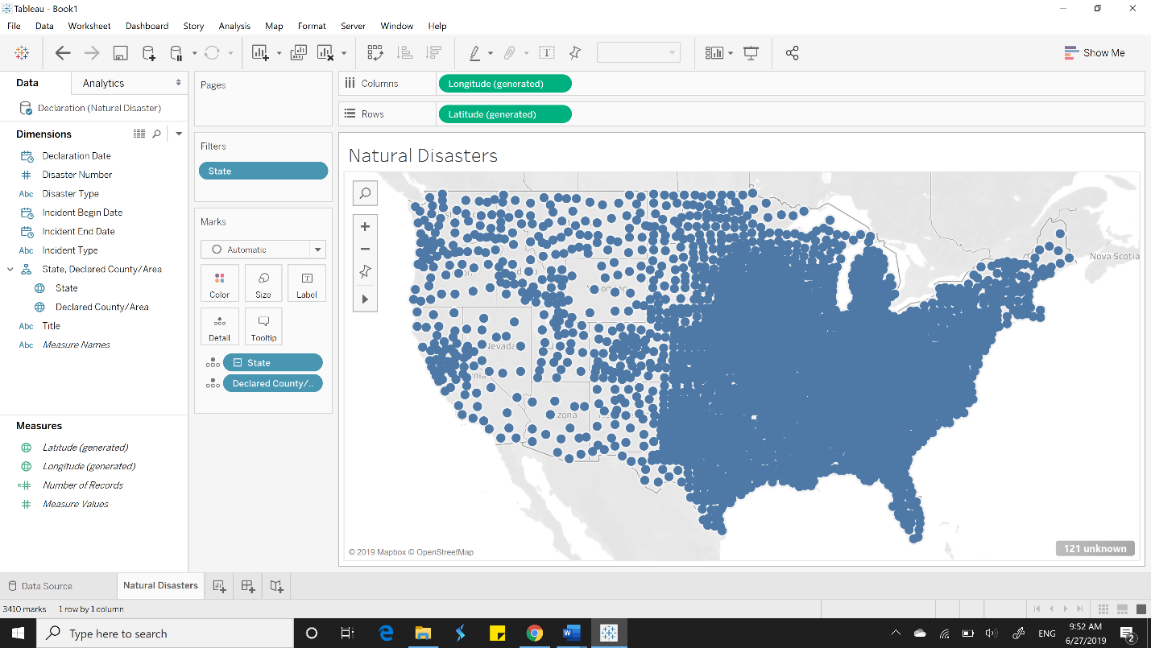

**B)**

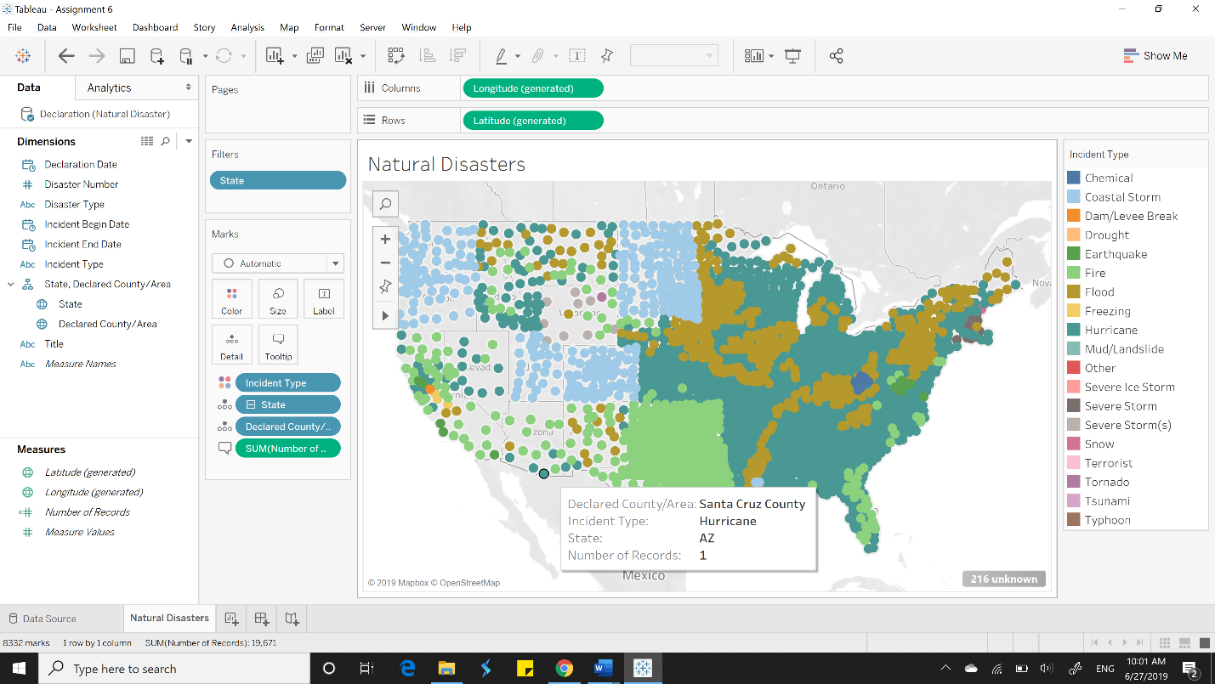

**C)**

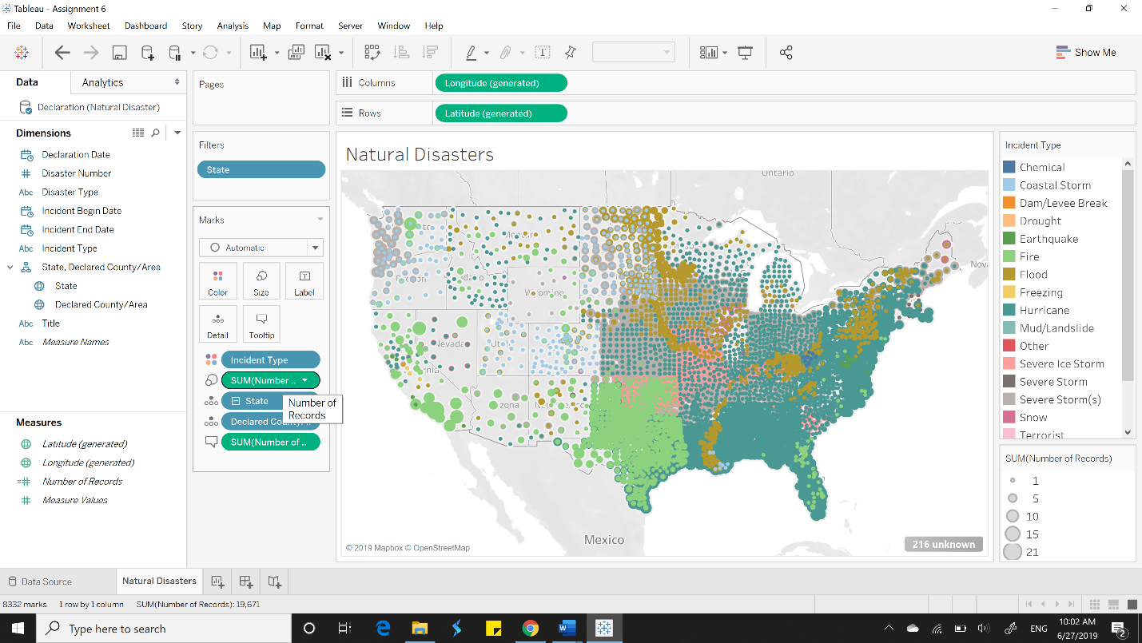

**D)**

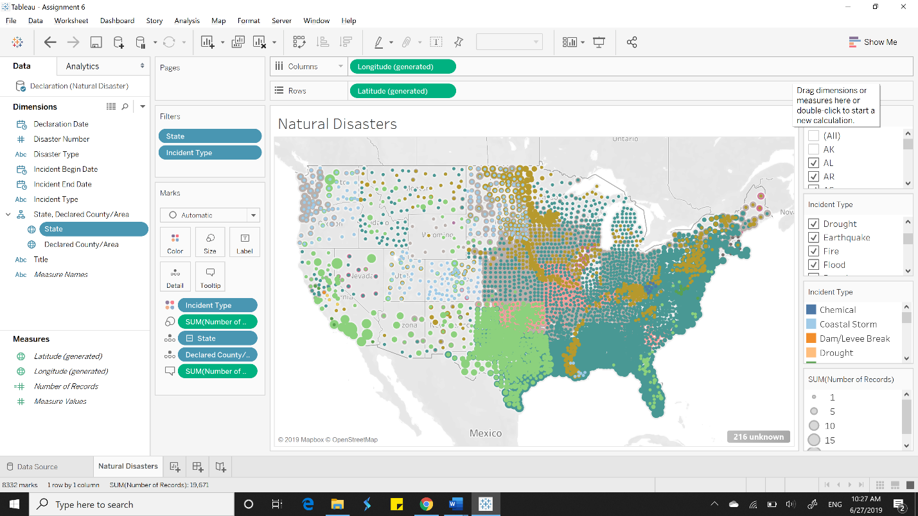

**I)**

|  |  |  |
| --- | --- | --- |
| Refinery Name | County | State |
| Shell Chemical LP Saraland Refinery | Mobile | AL |
| Shell Oil Martinez Refinery | Contra Costa | CA |
| Shell Oil Wilmington Refinery | Los Angeles | CA |
| Shell Chem LP Saint Rose Refinery | Saint Charles | LA |
| Shell Anacortes Refinery | Skagit | WA |

**J)**

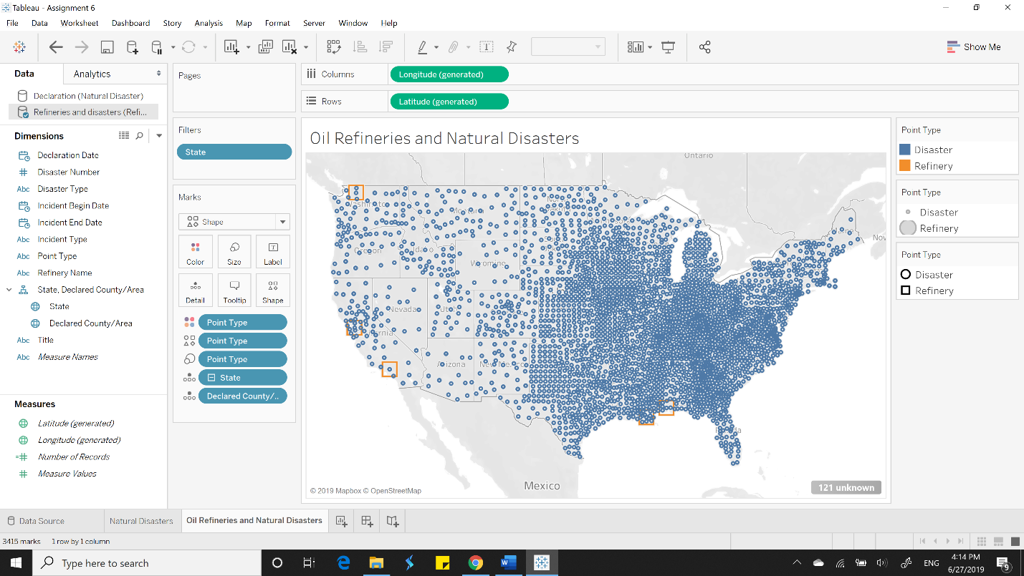

**K)**

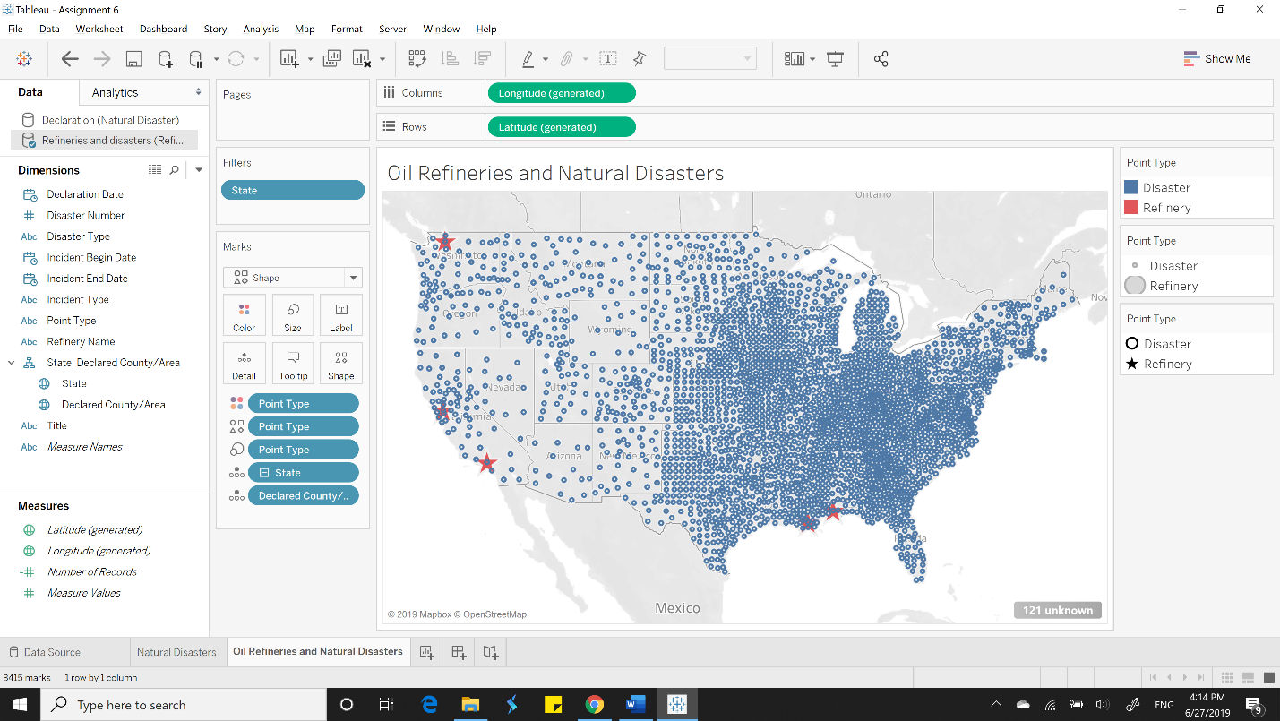

**L) Washington, California, Alabama, Louisiana**

**M)**

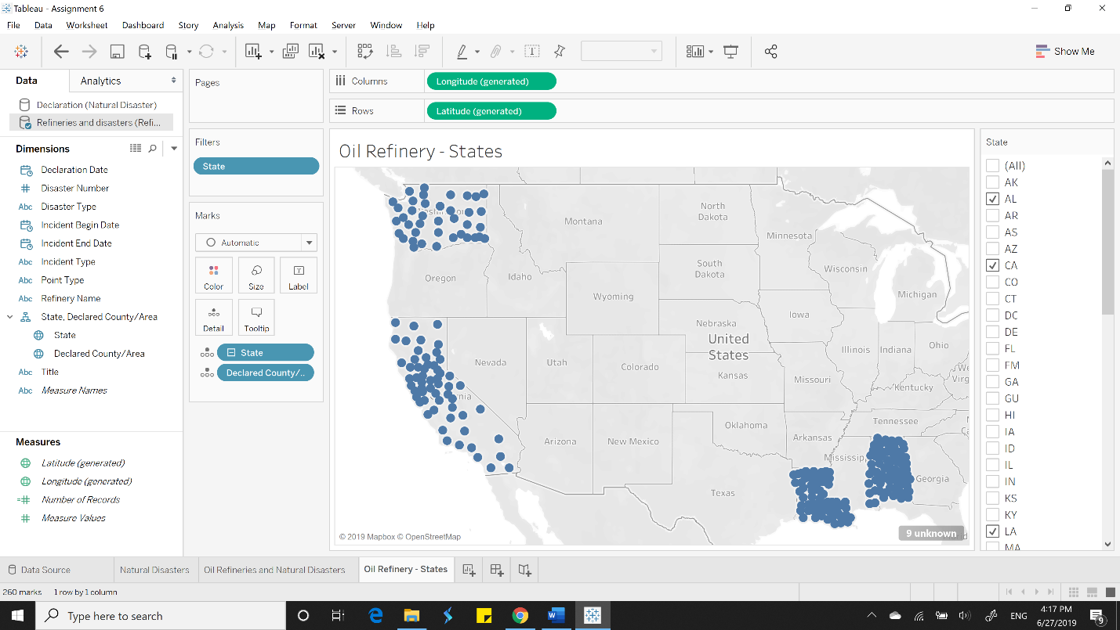

**N)**

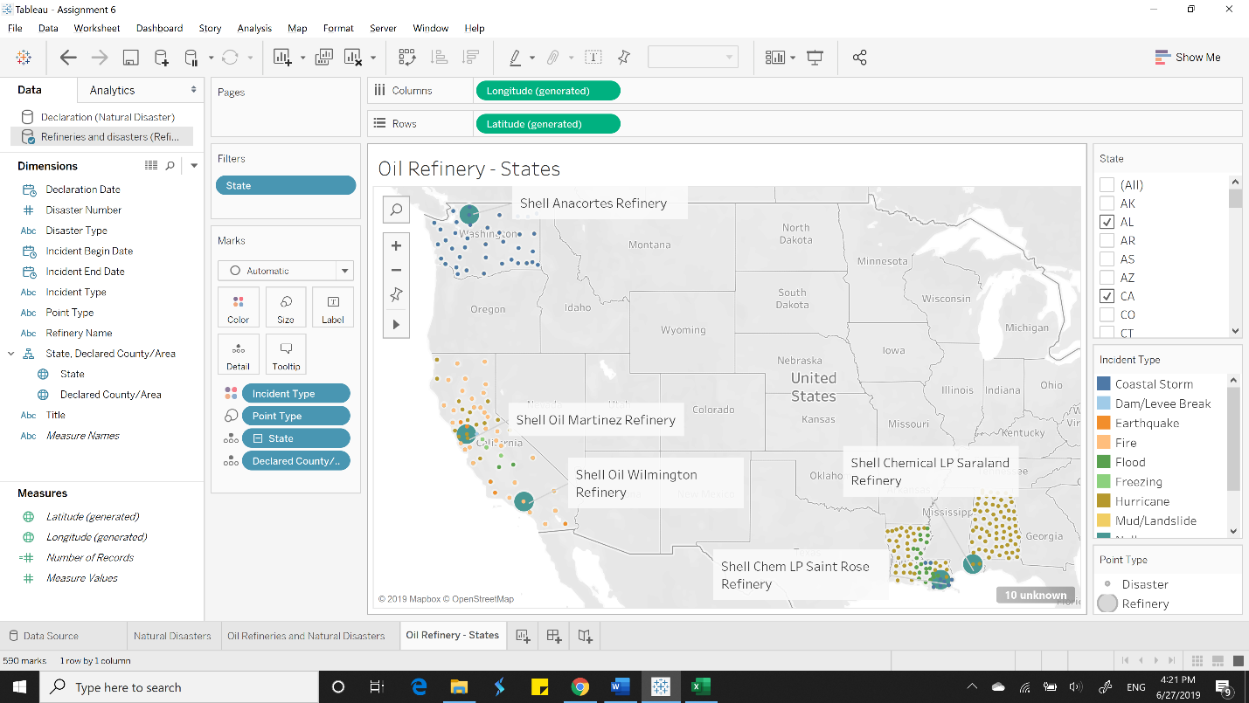

**O) Alabama- Hurricane; Washington- Coastal Storm**

**P)**

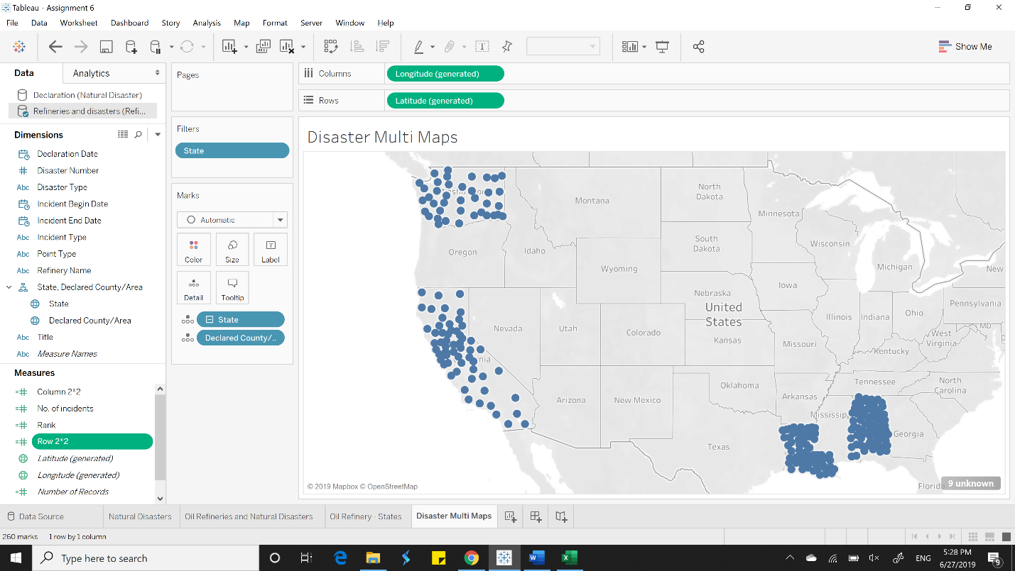

**Q) Hurricane**

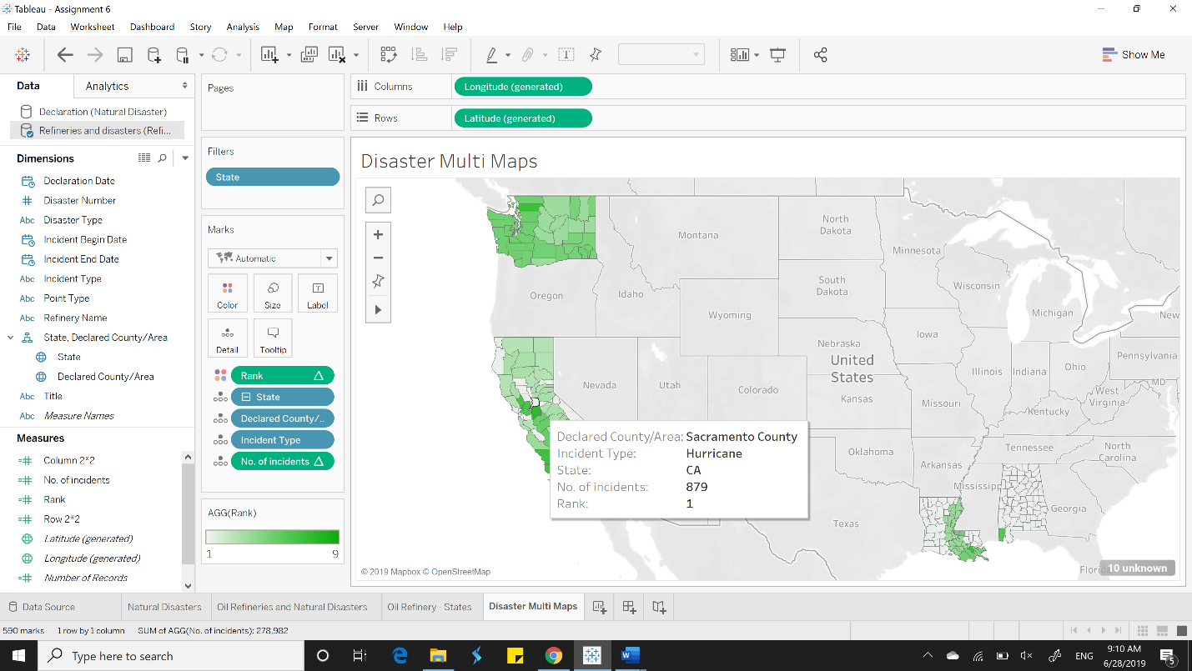

**R)**

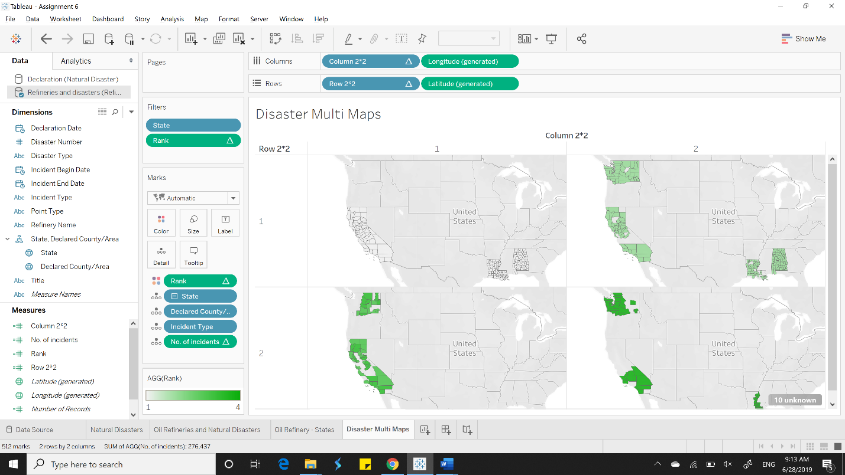

**S)**

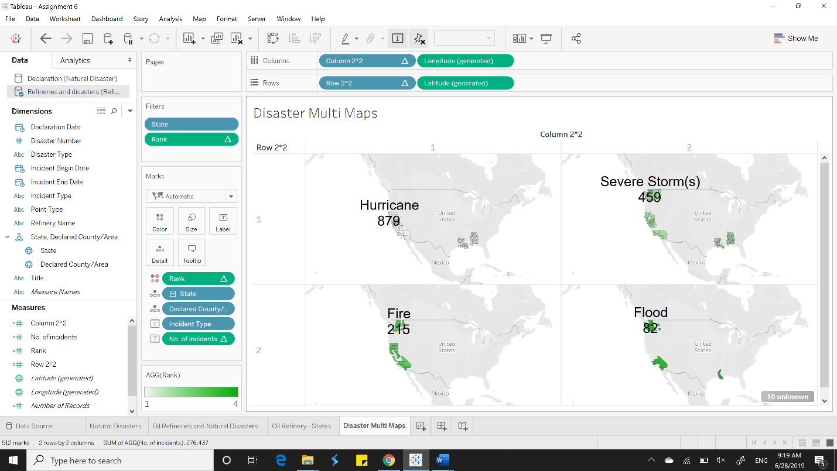

**U)**

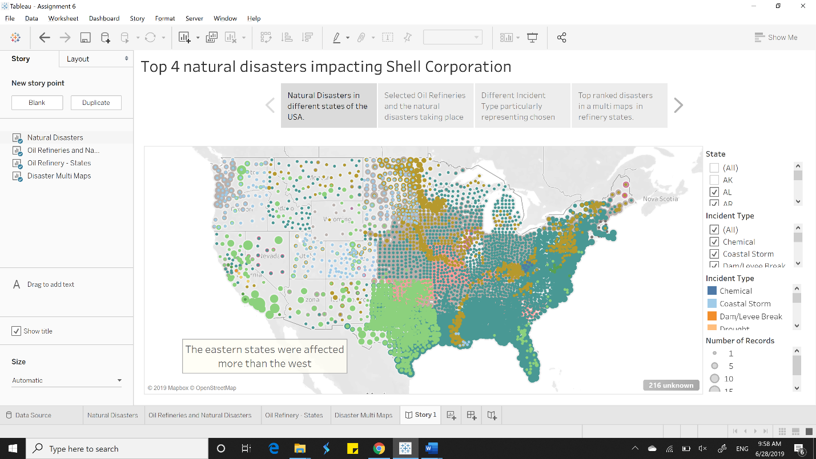

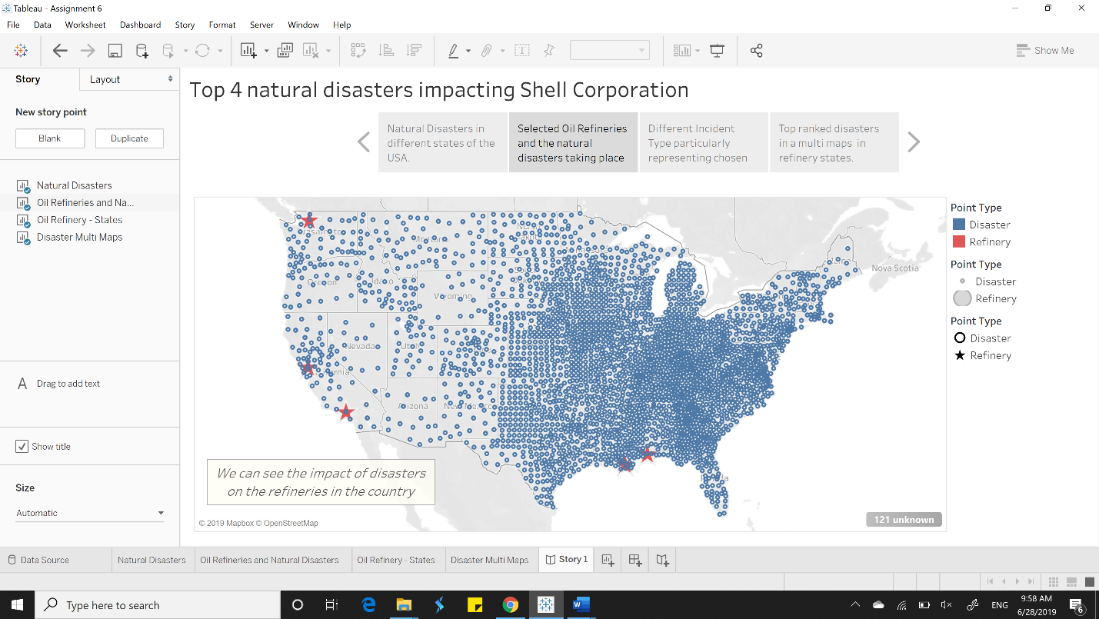

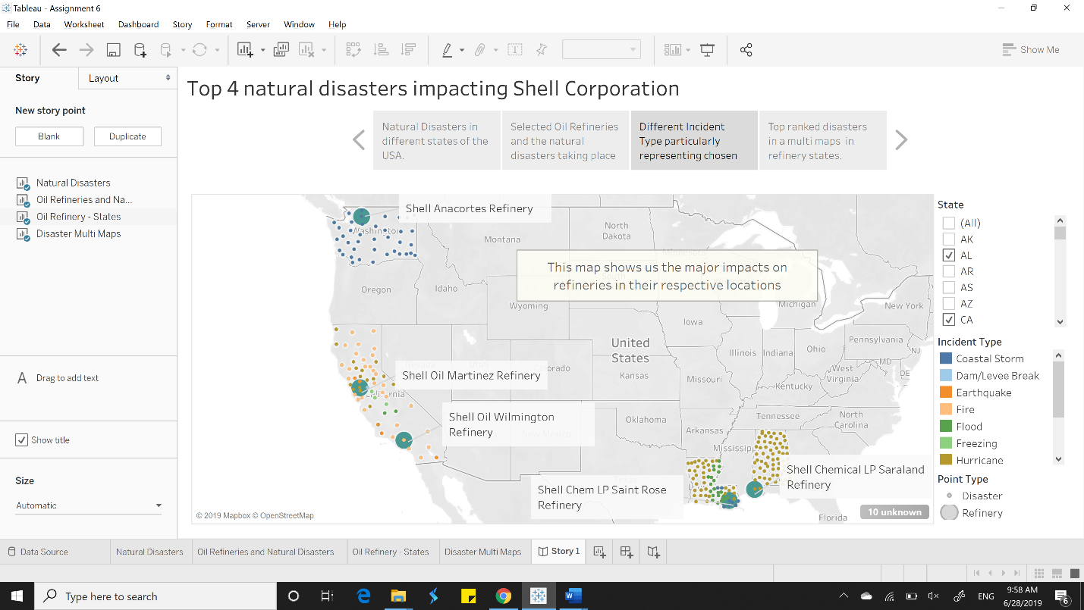

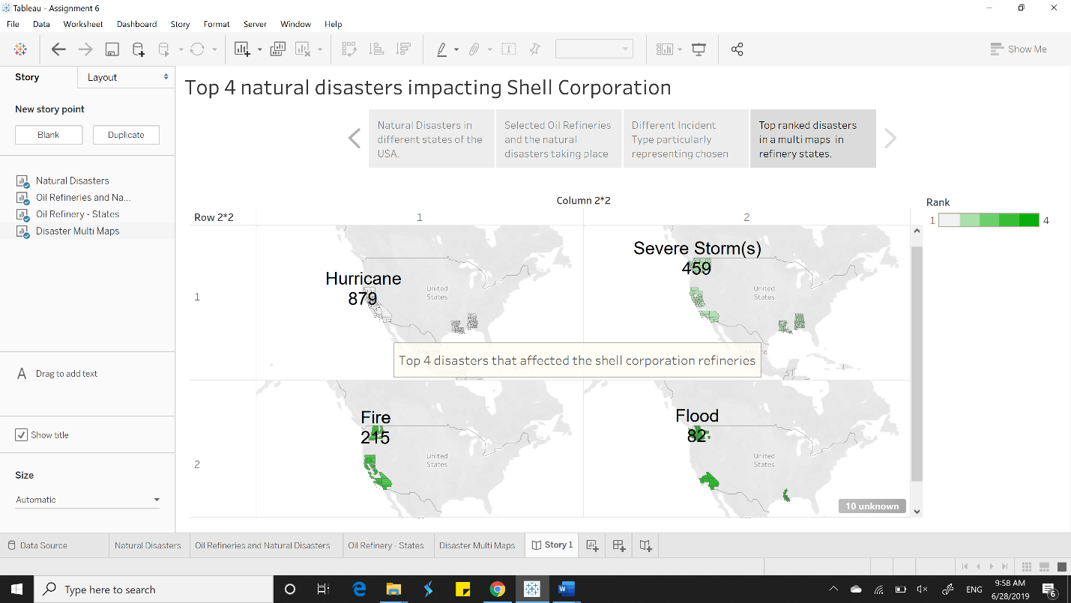

**The Rhetoric used was LOGIC. I used LOGIC because I need to convince my audience using logic or reason. We can do this using facts, historical data and citing information from certain reliable sources.**

**It was most apt to use this because we are trying to convey an interpretation from the data available. It makes sense to look at the type of disasters in the refinery states so that we can take proper care or precautions**